Name:  Class: | ____________________________________  ________________ | Date:_________
 | Year 8 Mathematics 2019  / 5  Investigation #1 – Part 1  Perimeter and Area  Resources Allowed: Personal notebook/ calculator/ graph paper/ ruler  Time allowed: 1 full class lesson and take home what is not completed

In this investigation you are tasked with designing a new Australian rules football playing field. The umpires are getting frustrated with the current designs because there are no fixed dimensions meaning that no two fields are the same. The fields are typically between 135 -185 metres long goal-to-goal and 110-155 metres wide wing-to-wing. The grounds can vary from long and narrow to almost circular, and are not necessarily symmetrical, depending upon how and where the field was constructed.
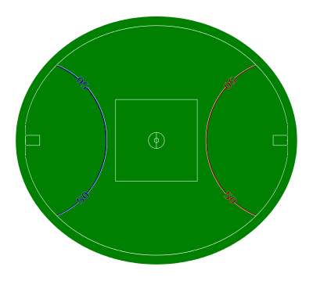
50 metre line
Goal area
Boundary Lines
Inner centre
Outer centre
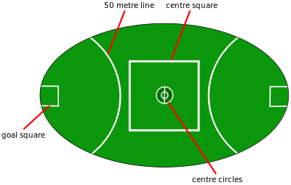

Question 1: Field Design 15 marks

Design your new playing field on a separate piece of paper.
Your new design must include the following:

- The boundary must be a rectangle with a total area of between 15,000-25,000 m²
- At least three of the following shapes:
    - Triangle
    - Parallelogram
    - Trapezium
    - Kite
- No curved lines or circles
- ‘Inner’ Centre area for the bounce down with an area between 100-300 m²
- ‘Outer’ Centre area where the midfielders stand with an area between 1,000 and 3,000 m²
- A set of goal posts and 50 m line at each end of the field
- With a goal area directly in front with an area between 200 and 400 m²

Make sure all of the dimensions are labelled clearly
Question 2: Area

Find the area of each shape on your field design.
Keep your working out neat and organized and use appropriate units.

Question 2: Line markings

How much would it cost to paint all the lines on your field if painting each meter cost $0.45?
Name:  Class: | ____________________________________  ________________ | Date:_________
 | Year 8 Mathematics 2019  / 20  Investigation #1 – Part 2 Validation  Perimeter and Area  Resources Allowed: Personal notebook/calculator/ Part 1 / Field Design  Time allowed: 1 full class lesson

For Part 2 validation you will be using the given field design. Part 1 will help guide you through the process but only us e the measurements in the given field design.

Question 1: Area 7 marks

Find the area of each of the following shapes from the given field design.

Total field area within the boundary lines:

Inner centre:

Outer centre area:

Question 2: Line markings 8 marks

The umpires have agreed upon this design and now need to change all 17 AFL grounds. They have been quoted by a turf painting company that it will cost $0.32 to paint each metre of the new lines on the footy grounds. What will the total cost be for all 17 footy grounds to have the new lines painted?

Question 3: Safety fencing 5 marks

For safety reasons there needs to be 5m between the boundary lines of the field and the fence which spectators must stay behind so as not to get injured. How much fencing is required for this field? Draw a diagram.

